IT24104013

Manage M D N S

PS -LabSheet 05

Exercise

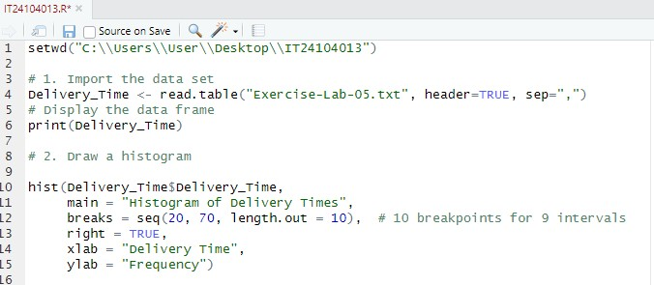

3. Comment on the shape of the distribution.

The histogram shows a right-skewed distribution with most delivery times concentrated towards the lower end.

